# **ADXL345 Digital Accelerometer**

**Characteristics :**

The ADXL345 is a low-power, 3-axis MEMS accelerometer modules with both **I2C** and **SPI** interfaces. The Adafruit Breakout boards for these modules feature on-board 3.3v voltage regulation and level shifting which makes them simple to interface with 5v microcontrollers such as the Arduino.  
The ADXL345 features 4 sensitivity ranges from +/- 2G to +/- 16G. And it supports output data rates ranging from 10Hz to 3200Hz.

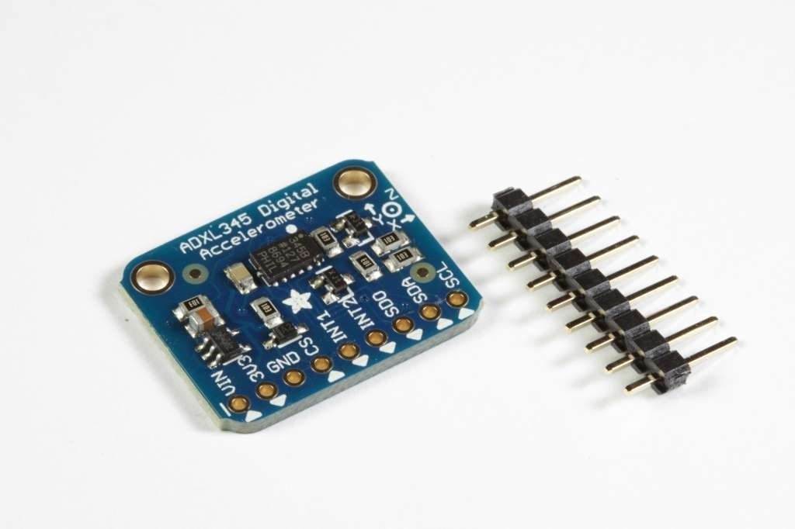

The sensor consists of a micro-machined structure on a silicon wafer. The structure is suspended by polysilicon springs which allow it to deflect smoothly in any direction when subject to acceleration in the X, Y and/or Z axis. Deflection causes a change in capacitance between fixed plates and plates attached to the suspended structure. This change in capacitance on each axis is converted to an output voltage proportional to the acceleration on that axis.

**COMMUNICATION I2C :**

The ADXL345 Breakout has an I2C address of 0x53. It can share the I2C bus with other I2C devices as long as each device has a unique address. Only 4 connections are required for I2C communication:

* GND->GND
* VIN->+5v
* SDA->SDA (Analog 4 on "Classic Arduinos")
* SCL->SCL (Analog 5 on "Classic Arduinos")

The Adafruit breakout has level shifting and regulation circuitry so you can power it from 3-5V and use 3V or 5V logic levels for I2C.

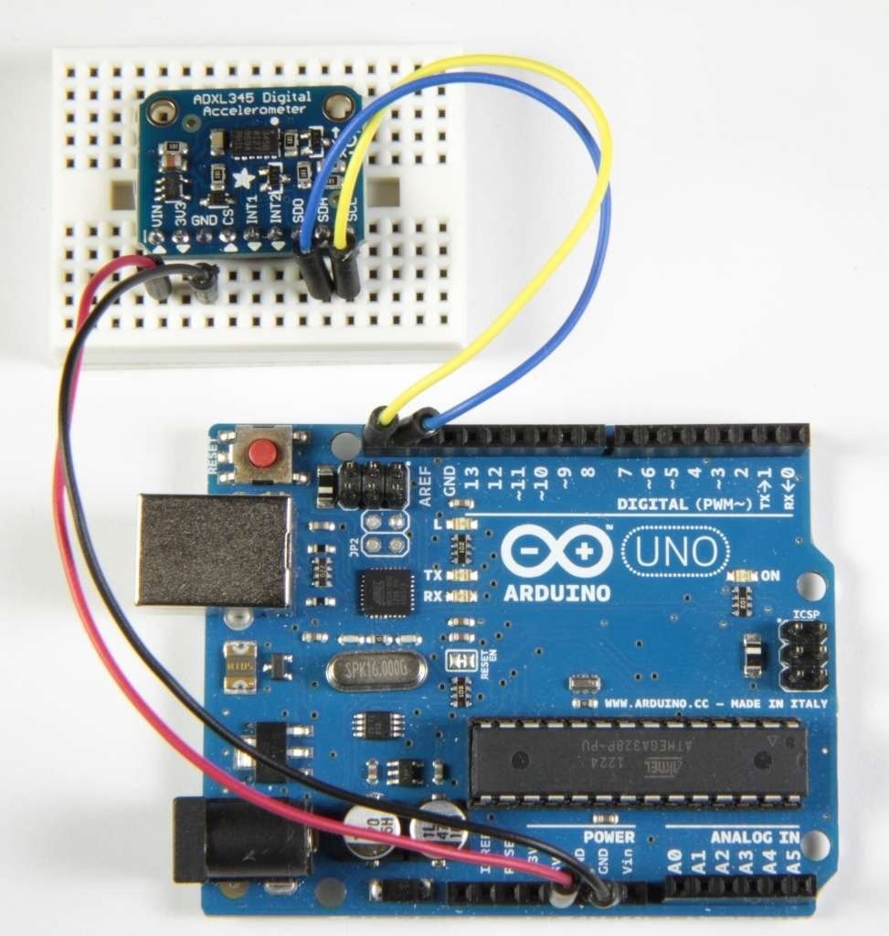

**CALIBRATE :**

The ADXL chips are calibrated at the factory to a level of precision sufficient for most purposes. For critical applications where a higher degree of accuracy is required, you may wish to re-calibrate the sensor yourself.  
  
Calibration does not change the sensor outputs. But it tells you what the sensor output is for a known stable reference force in both directions on each axis. Knowing that, you can calculate the corrected output from a sensor reading.

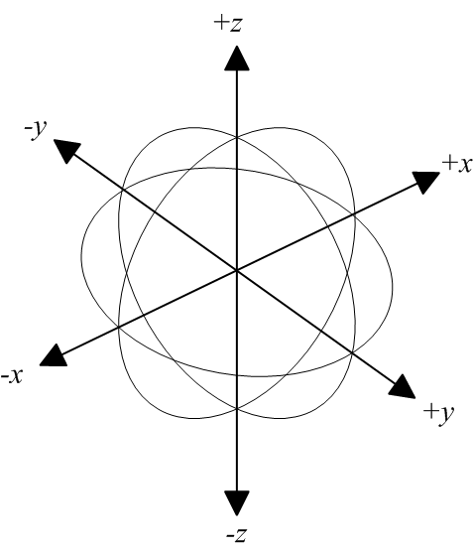

## **Gravity as a Calibration Reference :**

Acceleration can be measured in units of gravitational force or "G", where 1G represents the gravitational pull at the surface of the earth. Gravity is a relatively stable force and makes a convenient and reliable calibration reference for surface-dwelling earthlings.

## **Calibration Method:**

To calibrate the sensor to the gravitational reference, you need to determine the sensor output for each axis when it is precisely aligned with the axis of gravitational pull. Laboratory quality calibration uses precision positioning jigs.